# Q2:

Class Diagram:

Idea: 1 circle with radius can have n number of points hence 1 to n relationship

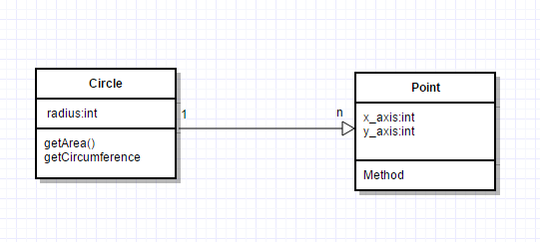

The idea